

Name: Tan Khoon Eam

Login ID: tankhoon@oasis-portal.com

Course title: Accounting Fundamentals

Subject Code: BHM03

Submitted date: 07/08/2017

**Table of Contents**

|  |  |  |
| --- | --- | --- |
| **No** | **Details** | **Page** |
| 1 | Executive Summary | 2 |
| 2 | Introduction | 3 |
| 3 | Assignment Question |  |
|  | Question 1 | 4 - 5 |
|  | Question 2 | 6 - 8 |
|  | Question 3 | 9 – 10 |
|  | Question 4 | 11 |
| 4 | Conclusion | 12 |
| 5 | References | 13 |
|  | Appendix | 14 |

**Executive Summary**

In this module, I learnt about the important of business accounting. Firstly, I learnt about the basic activities of business accounting that consists identifying, recording and communicating the economic events in a company and by these activities present a financial statement to show company financial accounting information. Furthermore, I also learnt about how to analyze income and expenses, overall picture of the business’s financial health and also what is bookkeeping, double entry system and accounting reporting documents. Other than this, I also learnt about the different between account payable and account receivable, the proper ways to do accounting recording. Lastly, after I studied this module I able to identify what is balance sheet, what is net profit and net loss, assets, liabilities etc.

**Introduction**

Accounting is very crucial part of business’s finance, for every business no matter small business or big corporate business. Without accounting information, there is no way to get know how does a company sales and revenue performance. Accounting also serves as an indicator for the growth prospect of the business, without basic information for the likes of profit and expenses, there’s no justification of how healthy is the business that’s important to warrant for additional capital investment or identify places for improvements. To be precise, the module exposes us to learn the management and production of financial statements, payment of taxes for the company and reporting of financial information. The module further splits into crucial parts of accounting like the double entry of assets, trading and profit and loss accounts. Balance sheet, accounting concepts, accounts journal, and book keeping. After understanding each parts of the accounting, collectively, they show how’s the particular business is doing in term of numbers, and in standard format accepted widely, the outcome is even more important for a public listed company where investors of the company rely on the publish information to decide whether to continue stay invested with the company, therefore, the numbers recorded and shown does plays a role in affecting how people perceive the company and the business in general. The below figure shows the proper cycle in accounting.

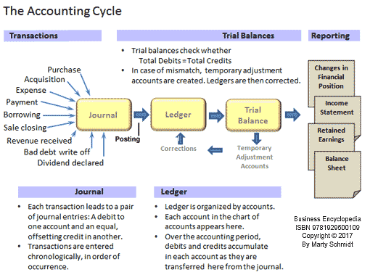

Figure 1

**Assignment Questions**

**Question 1**

In a brief but comprehensive response, define the role of accounting. (20 Marks)

Accounting is a system of recording transaction and is a process of summarizing financial flow of a business. Base on this accounting process can identifying a company profit or loss for a given period. It all about the debit and credit of two different side of account which is double entry system. From the accounting financial report, it can show how does a company performance regarding sales revenues, expenses, assets, liabilities, and cash flow all of this information allows business owners to assess the efficiency and effectiveness of their business operations. Apart from this, accounting information is important to prove or declare it to government for pay tax on business income without all this information may get fines or penalties.

History of accounting

Luca Pacioli who was known as the father of accounting born in 1446 in Sansepolcro. The contribution of Luca pacioli in accounting was honored by accountants around the world who gathered in San Sepulcro an Italian village to pay their huge tribute to his book published on double-entry accounting. The first accounting book which was published in 1494 was based on five sections in his mathematical book title in which he showed ‘Everything about Arithmetic, Geometry and Proportions’. Until the 16th century, this book written on accounting served as the only textbook on accounting around the world and due to this significant contribution, Luca Pacioli, was no doubt the father of accounting. He did not invent the system but he described the method which was used by merchants in Venice during the period of Italian Renaissance. The system he introduced in his book of accounting was mostly the accounting cycle which is well-known in the modern world of accounting. Luca Pacioli introduced the use of journals and ledgers in accounting systems and warned that the accountant must not sleep until the debits are equaled to credits. The ledgers he introduced were based on assets receivables and inventories, liabilities, capital, expenditure and income accounts. Friar Luca also demonstrated the entries which the companies can use for their yearend and he proposed the entry of trial balance for a balanced ledger. He also introduced wide range of topics ranging from accounting ethics to cost accounting. Today, no organization can ignore his proposed journal and ledger accounting system and then showing the balance of debits and credits to get the desired results for the organizations. This book was written on Geometry, Everything about Arithmetic and Proportions. In this book, he presented the guide to the already written mathematical knowledge and bookkeeping was one of the most important accounting topics covered in this book. He presented 36 short written chapters on bookkeeping in which he gave the necessary instructions in the conduct of business and given the traders precious information on accounting without any delay as to his assets and liabilities. Luca Pacioli also introduced numerous details about bookkeeping techniques which were followed in texts and in professions for the next four centuries. Accounting techniques were proved to be very effective for investors, business firms, lending institutions, and all the entire users of financial information are indebted to Luca Pacioli for his unbelievable and monumental role in the development of accounting. **(Accountant day info)**

Double Entry System

Every accounting will start with the double entry system and every financial transaction will be recorded by the double entry system.

For convenient to prepare the account double entry system, normally accountant will categories it into two aspect which is receiving aspect as ‘debit’ and giving aspect as ‘credit’.

Every transaction has two effects one of the account is debited another account must be credited.

The double entry system of accounting for every business transaction will involve two accounts (or more). For example,

1. A company borrows money from its bank, the company's Cash account will increase and its liability account Loans Payable will increase.

Dr Cash Cr Dr Loan Payable Cr

$ $ $ $

Loan Payable X Cash X

1. A company pays $200 for an advertisement, its Cash account will decrease and its account Advertising Expense will increase.

Dr Cash Cr Dr Advertisement Cr

$ $ $ $

Advertisement 200 Cash 200

There are few major roles for accounting which help to keep business running on with the financial information, regarding how well a business performance, track the sales revenue, the cost of benefits and the amount owe suppliers from here can easily make financial decisions. After collects all of this financial information a business owner can plan on future investment such as expand business, hiring more staff, plan on marketing and so on. If without all this information business owner not even know whether business earning profit or loss.

**Question 2**

What is the difference between accounts payable and account receivable? (20 marks)

Account payable is an account that we already received goods and service from others but we still not pay it which mean what we are still owing can referred as creditor.

Account Receivable is an account that we already provided goods and service to others but they still not pay it for us which mean people are owing for us can referred as debtor.

|  |  |
| --- | --- |
| Account Payable (creditor) | Account Receivable (Debtor) |
| * A current liability account * Money that company owes to others * Account payable are the amount that company owes because of purchase goods or service on credit from others * Account payable decrease company cash * Purchase goods with credit term * This account should have a credit balance * The amount that need to be pay | * A current asset account * Money that others owes to the company * Account receivable are the amount that not collect yet but goods or service already credit to others * Account receivable will increase company cash * Selling goods with credit term * This account should have a debit balance * The amount that need to be collect |

Example of double entry for account payable (Creditor) and receivable (Debtor)

1. A company sale $500 to Debtor A, Sale (income) account will increase and Debtor (assets) will increase.

Dr Sales Cr Dr Debtor A Cr

$ $ $ $

Debtor A 500 Sales 500

1. Paid cheque of $800 to Creditor A, Bank (assets) account will decrease and Creditor A (liability) will decrease.

Dr Bank Cr Dr Creditor A Cr

$ $ $ $

Creditor A 800 Bank 800

1. Bought goods of $600 from Creditor A, Stocks (Assets) will increase and Creditor A (liability) will increase.

Dr Stocks Cr Dr Creditor A Cr

$ $ $ $

Creditor A 600 Stocks 600

1. Debtor A paid $300 cash for settle debt, Debtor A (Assets) will decrease and Cash (Assets) will increase.

Dr Cash Cr Dr Debtor A Cr

$ $ $ $

Debtor A 300 Cash 300

1. Debtor A paid cheque $200 for settlement debt, Debtor A (Assets) will decrease and Bank (Assets) will increase.

Dr Bank Cr Dr Debtor A Cr

$ $ $ $

Debtor A 200 Bank 200

Account payable is a short time liability and need to be paid within 3 months or less than a year. Account payable process only can be done by receive few document, which is purchase order, report receiving, invoice from the company’s supplier, contracts and agreements.

The efficiency and effectiveness of the account payable process will affect the company’s cash position, credit rating and relationships with the supplier.

Account receivable is a service or goods provided to customers and the customers allowed to make their payment in a 30days time frame or base on the agreements, but not more than 3 months. Account receivable are also known as trade receivable.

It is important for a company to monitor its account receivable and to immediately follow up with any customers who has not paid as agreed. Before any new goods or service transaction provide. Some trade receivable that will never get to collect back need to be written off as uncollectable debt.

The uncollectable debt will turn to expenses, will place on the income statement as a sales expenses and it will decrease company profit.

**Question 3**

Why does a company’s profit appear as a credit on its balance sheet? (20 marks)

Balance sheet is a financial statement that summarizes a company’s assets, liabilities and equity. Base on a company’s balance sheet can screen though the company’s financial position so that investors have an idea as to what the company owns and owes. This is also valuable information for the banker who want to determine whether or not provide a company additional credit or loans.

Assets – Things that owns by the company that have certain value in the future economic and can be generate cash flow. Example, cash, inventory, equipment, land etc.

Liabilities – Things that owes by the company which are obligation of a company, they are amount that owes to other can refer as any debt or service owed to another party. Example, Salaries payable, loan payable, tax etc.

Equity – Equity is the money that business owner attribute into business for start a business, can be thought of as a source of the company's asset. Equity is equal to the asset amounts minus the liability amounts.

Sample of the balance sheet.

Company Name XXX

Dr Balance Sheet 31 DEC 2017 Cr

|  |  |
| --- | --- |
| Non-current assets $  Land XX  Machine XX  Equipment XX  XXX  Current assets  Stock XX  Cash XX  Debtor XX  XXXX | Equity and Capital $  Opening Capital XXX  (+) Net profit / (-) Net Loss XX  XXX  -Drawing (XX)  XXX  Current liability  Creditor XX  Office rental XX  Non-current liability  Bank loan XX  XXXX |

Accounting equation

The equation that is the foundation of double entry accounting. The accounting equation is Assets = Liabilities + Equity. The balance sheet is a complex display of this equation, showing that the total assets of a company are equal to the total of liabilities and equity.

The accounting equation could also be written as

Liabilities = Assets – Equity and Equity = Assets – Liabilities **(AccountingCoach)**

The reasons why company’s profit appear as credit side in balance sheet because equity is on the credit side and it show the wealth of the business and the profit fall under the equity that is the reasons why profit appear in the credit side of the balance sheet.

**Question 4**

What is meant by reconciling an account? (20 marks)

Reconciling an account mean process to ensure the figures that recorded in two separate set of account statement are accurate. Reconciling is the key process used to determine whether the money that received matches the amount spent, ensuring the two values are balanced at the end of the recording period.

The purpose of the bank reconciliation statement is tally up the different between bank statement and cash book. This will come across when there is different balance between the bank statement and the amount of the cash book different. Sometime, due to the difference timing of cutoff, omissions and errors made by the bank or firm itself that need to reconciliation statement.

The reasons cause it different between the cash book balance and the bank statement balance.

* Uncredited item – These items occurred when too close to the cutoff date of the bank statement. So, it will not appear on the current month statement and will appear on the following month.
* Unpresented cheques – Cheques that already issued by the firm but not presented to the bank for payment.
* Standing orders – Sometime have standing instructions from the firm to bank to make regular payment so it will auto debit in account itself. Example loan repayment, utilities bills etc.
* Direct debits – They are payment of directly pay through bank. They are some debtor that direct transfer payment through bank.
* Bank charges – The charges that charge by the bank for the banking services used. This will auto debit in the account and only will show by the end of the statement date.

Format of Bank Conciliation Service **(Slide share)**

______ Bank Reconciliation Statement as at XXXX______________ _______

$ $

Corrected balance in hand as per Cash Book X

Add Unpresented cheques X

Wrong credits by the bank X X

X

Less Bank deposits not yet entered on Bank Statement X

Wrong debits by the bank X X

X

**Conclusion**

Alongside with other business functions (i.e.: operations, productions, marketing, distribution, etc), accounting, be it performed inhouse or outsourced, plays a key role in representing the overall finance function of the company and business. Through the module, I have learnt that accounting plays as much importance in a healthy growing business, through the basic activities like identifying, recording and communicating the economic events of a company, business owners and investors have ways to analyze and interpret the wellbeing of the business and whether good for further expansion, without all the financial statements and records, the company will be operating blindly without indications of areas for improvements, excessive spending that needed to be controlled, and even whether marketing cost fairly translated to results. Besides understanding the crucial concept and importance of accounting, the modules also required us to pick up practical knowledges in term of double entry of assets, several types of accounts, journals and book-keeping. With the complete knowledge of business accounting, we can only come to appreciate the various important functions within the business and how each other cohesively contribute to the overall success of the organization.

**References**

1. Figure 1 - [https://www.business-case-analysis.com/images/accounting/accounting-cycle- accountant-role.png](https://www.business-case-analysis.com/images/accounting/accounting-cycle-%20accountant-role.png)
2. Online - Luca Pacioli – The Father of Accounting, Accountant day info, 2014 <http://accountants-day.info/index.php/international-accounting-day-previous/77-luca-pacioli>
3. Online - Accounts payable and receivable introductions, In slideshare, 20 July 2016,

<https://www.slideshare.net/altacitglobal/accounts-payable-and-receivable-introductions>

1. Online – Balance Sheet, AccountingCoach, Harold Averkamp (CPA, MBA),2017 <https://www.accountingcoach.com/balance-sheet/explanation/1>
2. Online – Accounting Equation, AccountingCoach, Harold Averkamp (CPA, MBA),2017 <https://www.accountingcoach.com/accounting-equation/explanation>
3. Online – Bank Reconciliation, Khalid Aziz, Jun 1, 2012, Slide share. <https://www.slideshare.net/khalid1173/bank-reconciliation-13157934>

**Appendix**

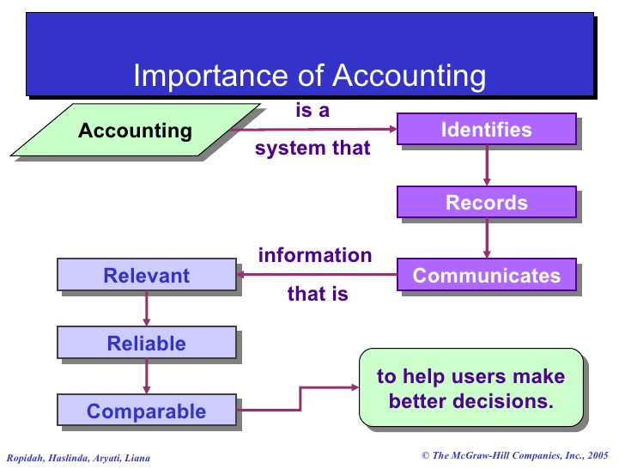

Important of accounting - <https://image.slidesharecdn.com/mujahidalichapter1-accountinginbusiness-090317003719-phpapp01/95/mujahid-ali-chapter-1-accounting-in-business-3-728.jpg?cb=1237250288>

THE END